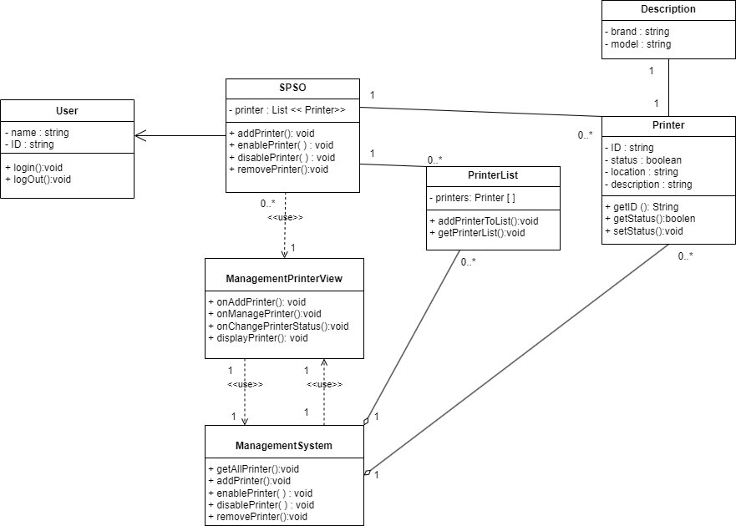

link : https://drive.google.com/file/d/1nH0DaGEAJDLYQitl1FLasyiC6174WrtA/view?usp=sharing